STUDENT UNION E-VOTING MODEL USING FACE RECOGNITION AUTHENTICATION

PROJECT PROPOSAL

Submitted by:

JACOB, MICHAEL EKPEME

21/SC/CO/1097

Department of Computer Science

University of Uyo, Uyo.

July, 2026

1. Background Knowledge
In today's digital age, the quest for more efficient, secure, and accessible voting systems has led to the exploration of innovative technologies. One such technology that has garnered significant attention is face recognition. Face recognition technology, once limited to security applications and mobile devices, is now being considered for integration into electronic voting (e-voting) systems. This integration offers the potential to revolutionize how student union elections are conducted (Kadir et al., 2023).
Voting is a method used by groups to make decisions or express opinions collectively, and it can take various forms. One significant advancement in voting technology is online voting, also known as e-voting, which has transformed traditional voting processes. By incorporating biometrics, e-voting has provided a more secure approach to voting in academic institutions compared to paper-based voting, which is prone to insecurity (Abdul-Kadir et al., 2023).
Traditional voting systems in Nigeria primarily rely on manual authentication methods, which involve the use of voting cards and identification documents. These methods, while foundational, have faced numerous challenges. The use of Voting Cards is a standard practice; however, manual verification at voting stations can be time-consuming and prone to errors. Polling officials manually check voter identification against the student voters' roll, a process susceptible to human error, leading to potential misidentification or impersonation (Okokpujie et al., 2021).
In recent elections, biometric verification using fingerprint scanners has been introduced. While this method improves security, it has limitations, such as technical glitches and difficulties reading fingerprints of certain individuals, especially those with worn or damaged fingerprints. Despite these efforts, traditional authentication methods have been insufficient in completely eliminating fraud and ensuring the integrity of the student union election process (Okokpujie et al., 2021).
Given the limitations of traditional authentication methods, there is a pressing need for more advanced solutions to ensure the security, integrity, and accessibility of student union elections. The advent of face recognition technology has ushered in a new era of identity verification and authentication. Its ability to accurately identify individuals based on unique facial features presents an opportunity to enhance the efficiency, security, and accessibility of student union election processes (Vashisht et al., 2022).
2. Statement of the Problem
The current voting systems, whether traditional paper-based or electronic, are fraught with several inefficiencies and vulnerabilities that compromise the integrity and accessibility of the student union election process. Key issues include voting fraud, long wait times, poor network infrastructure, logistical challenges, and difficulties in ensuring that only eligible student voters participate in student union elections. These problems not only undermine the accuracy and fairness of elections but also erode public trust in the student democratic process.
Traditional voting systems face challenges related to authentication, security, and accessibility. Instances of fraud, tampering, and disenfranchisement have underscored the need for more robust and transparent voting mechanisms. Omoweh (2017) reported that the manual recording and counting of ballot papers to select student union leaders has become difficult to manage. Election malpractices have consistently remained a bane of the Nigerian political system, with voter impersonation being a common form of political malpractice.
Given these challenges, there is a pressing need for a more secure, efficient, and accessible voting system that can accurately verify student voter identities and streamline the student union election process. This research investigates the potential of using facial recognition technology to address these problems by providing a smart voting system that enhances student voter verification, reduces fraud, and improves overall efficiency.
3. Aim and Objectives
The aim of this project work is to develop an e-voting system using face recognition authentication.
The specific objectives are:
- To design an interface for students' enrollment and verification.
- To design a web-based model for electronic voting in student union election.
- To assess the effectiveness of the proposed model by using test data collected and metrics such as accuracy and precision.

Table 1: Specific Objectives and Corresponding Methodology
Specific Objective | Data Needed | Method & Tool | Deliverable
Design an interface for students' enrollment and verification | Student registration numbers, facial images, personal details | OOAD prototyping; ASP.NET C# (Visual Studio); SQL Server; OpenCV / face recognition library | Functional enrollment & verification module
Design a web-based model for electronic voting in student union election | Candidate data, ballot structure, voting rules, student voter roll | ASP.NET C# web application; SQL Server database; web-based interface. | Fully functional web-based e-voting platform
Assess effectiveness of the proposed model using accuracy and precision metrics | Test votes, authentication logs, system response timestamps | Desk check, unit testing, integration testing; accuracy & response-time metrics | Performance evaluation report (accuracy ≥ 90%, avg. response ≤ 3.5 s)

4. Methodology
The methodology adopted for this research is the Object-Oriented Analysis and Design (OOAD) approach, combined with prototyping. OOAD involves studying an existing system from the perspective of objects, where similar objects are grouped into classes. Their characteristics are managed as properties, and their behaviors are handled as actions or methods within the same bundle of objects. This method was chosen because it provides a flexible and organized framework, ideal for building an e-voting system that is easy to use, can grow as needed, and can adapt to future demands.
The system was developed using Visual Studio and ASP.NET C#, with Microsoft SQL Server managing the database to ensure secure and efficient data handling. Program testing was conducted in three systematic phases:
- Desk Check: Each line of code was examined to identify syntax errors, logical inconsistencies, or structural discrepancies before execution.
- Unit Testing: User inputs such as user credentials, facial recognition images, and voting data were used to test the correctness of individual modules independently.
- Integration Testing: Data flow between the face recognition module, voting module, and the database were integrated and tested to ensure seamless interoperability.
System performance was evaluated using two key metrics: accuracy (proportion of correctly processed votes) and response time (duration taken to complete key system actions such as authentication and vote recording).
5. Scope of Study
The scope of this study includes the development and implementation of an e-voting system using facial recognition technology. The system will be designed to streamline and secure the student voter registration and voting process by leveraging advanced biometric authentication methods. The study focuses on creating a system that ensures only eligible registered students who are currently enrolled can register and vote, including the integration of the Student Registration Number for enrollment verification.
The system will be built using Visual Studio and ASP.NET C# for application development, with SQL Management Studio utilized for database management. The evaluation of the system will focus on performance metrics — specifically accuracy and response time — to ensure reliability and efficiency in real-world applications.
Additionally, the study will address the development of a user-friendly interface for student voter registration and a secure voting platform. This includes both online and offline voting functionalities to address potential network connectivity challenges. The study is limited to student union elections within the University of Uyo context.
6. Literature Review of Related Works
This section reviews existing literature on the use of technology in voting systems, focusing particularly on facial recognition technology and its application in e-voting.
6.1 Electronic Voting Systems
Buchsbaurn (2014) defined electronic voting (e-voting) as a term encompassing several different types of voting, embracing both electronic means of casting a vote and electronic means of counting votes. Biometric technologies work by measuring and analyzing human physiological or behavioral characteristics. Physiological characteristics include fingerprints, facial features, and iris patterns, while behavioral characteristics encompass voice patterns and typing rhythms.
6.2 Facial Recognition Technology
Face recognition technology stands as a sophisticated system enabling the identification or verification of individuals through the analysis and comparison of facial patterns from images or video frames. The technology maps facial features mathematically and compares them with a database of known faces, enabling accurate identification even in varying lighting and angle conditions (Bhimanwar et al., 2017).
6.3 Related Works
SUEC (2022) introduced the Student Voter Accreditation System (SVAS) in Nigeria's 2023 student union election, using both fingerprint and facial recognition to reduce voter impersonation and multiple voting. Limitations included technical failures due to poor infrastructure and difficulties with biometric recognition in varying conditions.
Domakonda et al. (2022) developed an E-Voting system using facial recognition to improve the security and reliability of the voting process. Limitations included challenges related to lighting conditions, the need for high-quality facial images, and computational resources required for real-time processing.
Kothawade et al. (2021) proposed a novel E-Voting system utilizing biometric thumb impressions and facial recognition for voter authentication. Limitations included the need for high-quality biometric data capture devices and potential issues with biometric recognition accuracy under varying environmental conditions.
Fernando et al. (2019) developed a face recognition system using deep neural networks with CNN to enhance accuracy. Limitations included high computational requirements for training and potential challenges with real-time processing in resource-constrained environments.
Sulaiman et al. (2021) developed an online voting system using face recognition for campus elections, implementing a secure and efficient voting process for academic institutions. Limitations included potential issues with facial recognition accuracy due to changes in appearance or lighting conditions.
Behrainwala et al. (2022) introduced a smart voting system using facial recognition to enhance security and efficiency. Limitations included potential issues with facial recognition in varying lighting conditions and the challenge of ensuring the system's scalability for larger elections.
6.4 Knowledge Gap
The literature review revealed that while various systems have introduced advanced biometric and encryption methods to secure the voting process, limitations such as technical reliability in regions with poor infrastructure, the accuracy of biometric recognition under diverse conditions, and the complexity of implementation remain prevalent. The proposed system seeks to overcome these challenges by incorporating offline functionality, enhancing biometric algorithms for better accuracy, and ensuring scalability and security tailored to the student union election context.

7. Block Diagram of System Architecture
The e-voting system architecture is composed of six core modules that work together to provide a secure, accessible, and efficient voting process:
- Facial Recognition Module: Responsible for capturing and processing facial images of voters. Uses advanced algorithms to identify and verify voter identities accurately.
- Student Voter Registration System: Allows eligible students to register as voters, including an interface for entering personal details and capturing biometric data.
- Registration Number Verification Module: Connects with the Student Registration Number database to validate the identity and eligibility of each voter.
- Voting Interface: Provides a user-friendly platform for voters to cast their votes, designed for both online and offline use.
- Database Management System: Built using SQL Server, stores all student voter information including personal details, facial recognition data, and voting records with encryption.
- System Administration Module: Allows authorized personnel to manage the system, update voter information, monitor system performance, and generate election reports.
The system supports two voting modes. In online mode, votes are cast and transmitted in real-time to the central database. In offline mode, votes are stored locally and synchronized once internet connectivity is restored.

Figure 1: Block Diagram of System Architecture
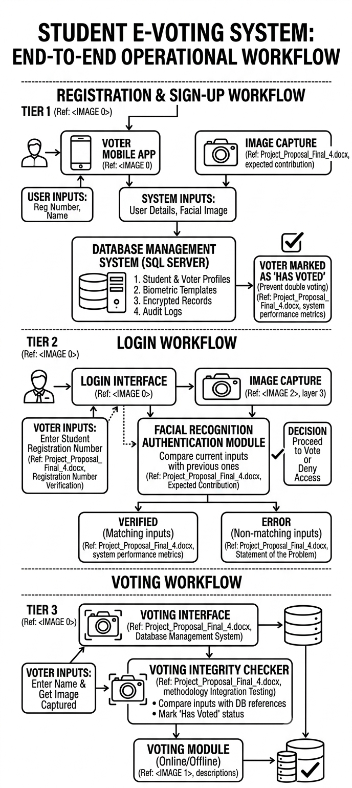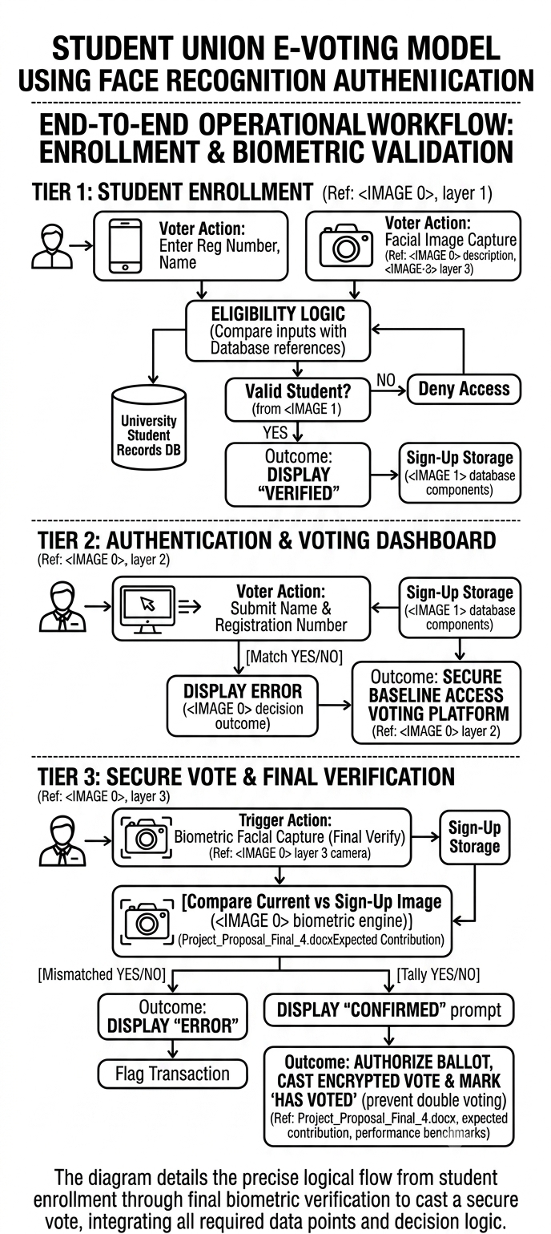

Table 2: Summary of Related Works
Author/Year | Objectives | Methodology | Limitations
SUEC (2022) | Reduce voter impersonation and multiple voting in student union elections. | Student Voter Accreditation System (SVAS) using fingerprint and facial recognition. | Technical failures due to poor infrastructure; difficulties with biometric recognition in varying conditions.
Domakonda et al. (2022) | Improve the security and reliability of the voting process. | E-Voting system using facial recognition. | Challenges related to lighting conditions, need for high-quality facial images, and computational resources for real-time processing.
Kothawade et al. (2021) | Achieve reliable voter authentication. | E-Voting system utilizing biometric thumb impressions combined with facial recognition. | Need for high-quality biometric data capture devices; recognition accuracy issues under varying environmental conditions.
Fernando et al. (2019) | Enhance the accuracy of face recognition. | Face recognition system using deep neural networks with Convolutional Neural Networks (CNN). | High computational requirements for training; challenges with real-time processing in resource-constrained environments.
Sulaiman et al. (2021) | Provide a secure and efficient voting process for academic institutions. | Online voting system using face recognition for campus elections. | Facial recognition accuracy affected by changes in appearance or lighting conditions.
Behrainwala et al. (2022) | Enhance the security and efficiency of the voting process. | Smart voting system using facial recognition. | Recognition issues in varying lighting conditions; challenge of ensuring scalability for larger elections.

8. System Flowchart
Figure 2 below illustrates the step-by-step flow of operations within the e-voting system, from the point a student accesses the portal through to the final recording of their vote and results generation.

Figure 2: System Flowchart of the Proposed E-Voting System

START
↓
Student Opens Voting Portal(Enter Registration Number)
↓
Verify Student Registration Numberagainst University Database
↓
Valid Student? [YES → continue] [NO → deny access]
↓
Capture Facial Image for Authentication
↓
Run Facial Recognition Module(Compare with stored biometric)
↓
Face Matched? [YES → proceed] [NO → retry / deny]
↓
Display Ballot / Candidate List
↓
Student Casts Vote(Online Mode: real-time | Offline Mode: local storage)
↓
Encrypt & Store Vote in SQL Server Database
↓
Mark Voter as 'Has Voted'(Prevent double voting)
↓
If Offline: Sync to Central DB when online
↓
Results Calculation &Report Generation (Admin Module)
↓
END

Figure 2: Operational flowchart showing authentication and voting process flow

9. Expected Contribution to Knowledge
This study is expected to contribute to knowledge in the following ways:
- Enhanced Electoral Integrity: The facial authentication technique will help in identifying ineligible voters, thereby preventing unauthorized access to the voting system and reducing election malpractice.
- Improved Voter Experience: The streamlined registration and authentication processes will reduce wait times and logistical challenges, making voting more convenient and time-efficient.
- Innovation in Voting Systems: The integration of facial recognition technology represents a significant advancement in the field of electoral systems, demonstrating a practical application of biometric technology in student union governance.
- Scalable Architecture: The system's scalable architecture ensures that it can be adapted to different student election contexts and scales, providing a versatile solution for various institutional electoral needs.
- Dual-Mode Voting: The successful implementation of both online and offline voting functionality provides a practical model for handling network connectivity challenges common in Nigerian institutions.
- Performance Benchmarks: The documented accuracy rate of 90% and average response time of 3.5 seconds provide baseline benchmarks for future improvements to biometric e-voting systems.

10. References
Abbas, Q., Javaid, S., & HussnainAbass, T. (2018). Location-free Voting System with the help of IOT Technology. In 2018 International Conference on Computing, Mathematics and Engineering Technologies. https://doi.org/10.1109/icomet.2018.8346407
Abdul-Kadir, M. F., Mohamed, M. A., Bharun, A., Mohd Satar, S., & Abd. Hamid, N. (2023). A secure online voting system using face recognition technology. Malaysian Journal of Computing and Applied Mathematics, 6, 1-9. https://doi.org/10.37231/myjcam.2023.6.1.80
Abdullahi, S.A. (2015). Youth, political parties and electoral violence in Nigeria. In Mohammed, H. (Ed.) The patterns and dynamics of electoral violence in Nigeria. Friedrich-Ebert-Stiftung.
Behrainwala, A., Saxena, A., Navlani, A., Sahay, S., & Tarapore, N. (2022). Smart voting system using facial recognition. International Journal for Research in Applied Science and Engineering Technology, 10(1), 308-313. https://doi.org/10.22214/ijraset.2022.39810
Bhimanwar, C., Bhole, N., Biradar, R., & Rane, M. (2017). Face Identification. International Journal of Engineering Sciences & Research Technology, 6(4).
Buchsbaurn, E. (2014). Toward secure and practical E-elections in the new era. In proceedings of international conference on security and management. CSREA Press.
Domakonda, S., Nishitha, D., Kumar, A. Y., Rao, A. S., & Sindhu, A. (2022). E-Voting System Using Facial Recognition. The International Journal of Analytical and Experimental Modal Analysis, XIV(VI), 1191-1201.
Fernando, E., Andwiyan, D., Fitria Murad, D., Touriano, D., & Irsan, M. (2019). Face recognition system using deep neural network with convolutional neural networks. Journal of Physics: Conference Series, 1235(1), 012004. https://doi.org/10.1088/1742-6596/1235/1/012004
Srinivas, T.S., Goutham, T., & Kumaran, M. S. (2022). Face Recognition-based Smart Attendance System Using IoT. International Journal of Early Childhood Special Education, 14(3).
Sruthi, M. S., & Shanjai, K. (2021). Automatic voting system using convolutional neural network. Journal of Physics: Conference Series, 1916(1), 012202.
SUEC. (2022). Enhancing voter authentication using dual biometric technology: Fingerprint and facial recognition. Student Union Electoral Commission Report.
Sulaiman, M. M., Othman, M. F. I., Md Shah, W., Hassan, A., Harum, N., & Mohammed Alseadoon, I. (2021). An online voting system using face recognition for campus election. Journal of Advanced Computing Technology and Application (JACTA), 3(1), 37-42.
Vashisht, V. L., Mohan, H., & Prakash, S. (2022). Smart Voting System Through Face Recognition. In 2022 4th International Conference on Advances in Computing, Communication Control and Networking (ICAC3N) (pp. 909-913). doi: 10.1109/ICAC3N56670.2022.10073982

